Embargoed until 26. April 2024
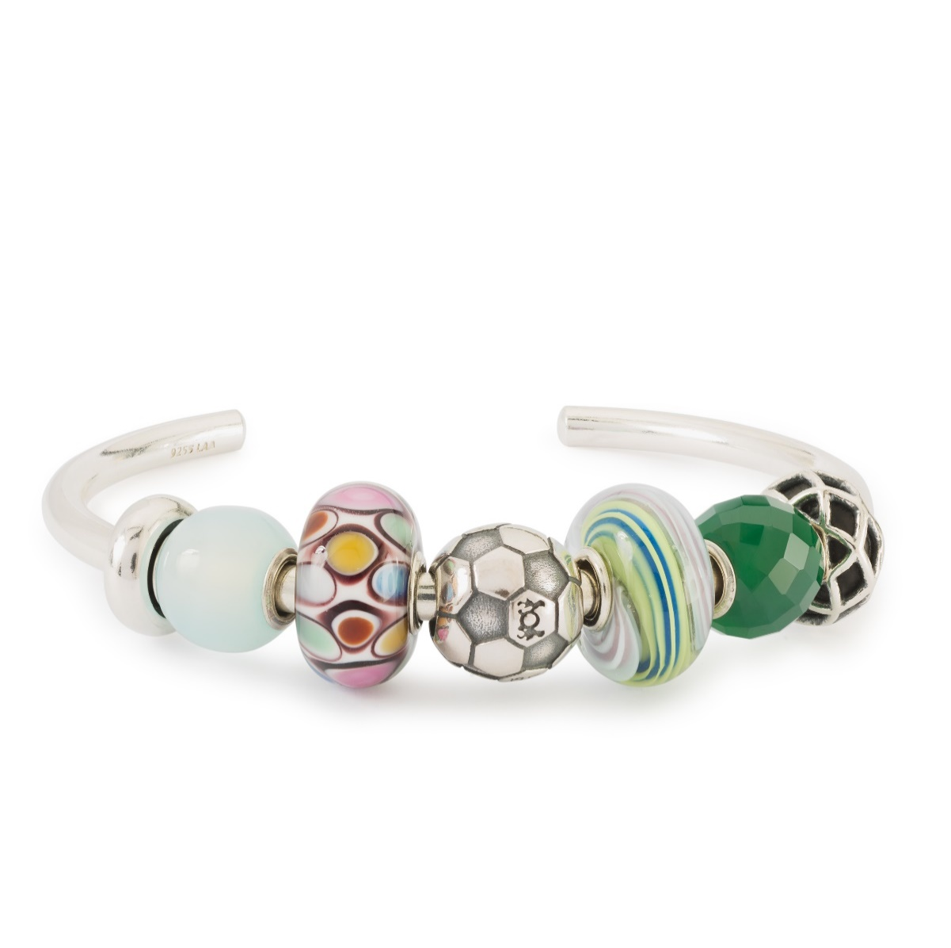
Football Passion: Celebrating the Unsung Heroes of the Game

A tribute to the world's most popular sport and all those who contribute to making it possible.
Experience craftsmanship at its finest with Trollbeads' new release.

As the world's most beloved sport, football ignites a passion that transcends borders and unites communities. Yet, amidst the spotlight on champions, there are often unseen heroes – the supporters.
These unsung heroes, be they mothers or fathers, stand proudly on the sidelines, their unwavering devotion lighting the path for future stars. From frosty winter mornings to late summer afternoons, they brim with pride as they witness the joy and determination in their children's eyes.
Trollbeads Football Passion bead celebrates these heroes. Symbolizing the spirit of unity, camaraderie, and unwavering support, it encapsulates the essence of football's enduring legacy, inspiring generations to come.
Available in both sterling silver and 18K gold, the Football Passion bead offers a timeless tribute to the love of the game. ⚽
#FootballPassion #UnsungHeroes #ChampionsOfTomorrow #DiscoverTrollbeads

Prices:
Bangle with bead as shown: € 425.
The collection is available in stores and online from 24. May 2024

For further information, high resolution images etc., please contact: Insert local PR contact

